Northwest District

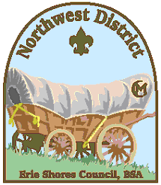

**Award Nomination Form**

**CUB SCOUT OF THE YEAR**

Name of Cub Scout:_________________________________ Pack: _________

Years of scouting: _____________

Ranks Completed: ______________________________________________________

Other Scouting Accompishments_____________________________________________

_______________________________________________________________________

Person submitting nomination:(Optional)_________________________________________

Briefly describe what traits this person displayed as a Scout: ___________________

_______________________________________________________________________

_______________________________________________________________________

How did this person uphold the values of Scouting?______________________________

_______________________________________________________________________

_______________________________________________________________________

Non-scouting honors/leadership experiences: __________________________________

_______________________________________________________________________

_______________________________________________________________________

Other information or awards earned: ______________________________________

_______________________________________________________________________

_______________________________________________________________________

***Please submit to Scout Service Center or e-mail to:***

**Northwest District:** [**pat.keenan@scouting.org**](mailto:pat.keenan@scouting.org) **(OR)**

**Northwest District Commissioner:** [**amroz@bex.net**](mailto:amroz@bex.net)